1)Vision models from different service provides (other than groq)
2)Try with meta chat in whatsapp
3)Check the cutoff date for Chatgpt,Qwen and Deepseek
4)Search for a Testscript or testcases with Thinking and normal model in chatgpt,Qwen and deepseek
(any domain or your office app)
5)Use the tokenizer to calculate the tokens for different prompts (with space ,with special characters without space etc)
https://platform.openai.com/tokenizer
6)From Openrouter ai --Extract the values of
1)Context window
2)Input tokens(with price)
3)Output token (with price)
For
openai/gpt-oss-120b
openai/gpt-4o-mini
openai/gpt-5.2
anthropic/claude-sonnet-4.5
anthropic/claude-opus-4.5
anthropic/claude-haiku-4.5
google/gemini-2.5-flash
google/gemini-3-pro-preview
google/gemini-2.0-flash-001
qwen/qwen3-235b-a22b-2507
qwen/qwen3-vl-235b-a22b-instruct

https://platform.openai.com/docs/models

- Vision models from different service provides (other than groq)
LLAMA 4 SCOUT
Need a simple code for booking tickets in bus.
class Bus:
def __init__(self, bus_number, seats):
self.bus_number = bus_number
self.seats = seats
self.booked_seats = []

def book_ticket(self, passenger_name, seat_number):
if seat_number in self.booked_seats:
print("Seat already booked. Please choose another seat.")
elif seat_number > self.seats or seat_number <= 0:
print("Invalid seat number. Please choose a seat between 1 and", self.seats)
else:
self.booked_seats.append(seat_number)
print(f"Ticket booked for {passenger_name} on seat {seat_number} in bus {self.bus_number}")

def cancel_ticket(self, seat_number):
if seat_number in self.booked_seats:
self.booked_seats.remove(seat_number)
print(f"Ticket cancelled for seat {seat_number} in bus {self.bus_number}")
else:
print("Seat is not booked.")

def display_status(self):
print(f"Bus Number: {self.bus_number}")
print(f"Total Seats: {self.seats}")
print(f"Booked Seats: {self.booked_seats}")
print(f"Available Seats: {self.seats - len(self.booked_seats)}")

class BusTicketBookingSystem:
def __init__(self):
self.buses = {}

def add_bus(self, bus_number, seats):
self.buses[bus_number] = Bus(bus_number, seats)

def book_ticket(self, bus_number, passenger_name, seat_number):
if bus_number in self.buses:
self.buses[bus_number].book_ticket(passenger_name, seat_number)
else:
print("Bus not found.")

def cancel_ticket(self, bus_number, seat_number):
if bus_number in self.buses:
self.buses[bus_number].cancel_ticket(seat_number)
else:
print("Bus not found.")

def display_bus_status(self, bus_number):
if bus_number in self.buses:
self.buses[bus_number].display_status()
else:
print("Bus not found.")

def main():
booking_system = BusTicketBookingSystem()

while True:
print("\n1. Add Bus")
print("2. Book Ticket")
print("3. Cancel Ticket")
print("4. Display Bus Status")
print("5. Exit")

choice = input("Enter your choice: ")

if choice == "1":
bus_number = input("Enter bus number: ")
seats = int(input("Enter total seats: "))
booking_system.add_bus(bus_number, seats)
elif choice == "2":
bus_number = input("Enter bus number: ")
passenger_name = input("Enter passenger name: ")
seat_number = int(input("Enter seat number: "))
booking_system.book_ticket(bus_number, passenger_name, seat_number)
elif choice == "3":
bus_number = input("Enter bus number: ")
seat_number = int(input("Enter seat number: "))
booking_system.cancel_ticket(bus_number, seat_number)
elif choice == "4":
bus_number = input("Enter bus number: ")
booking_system.display_bus_status(bus_number)
elif choice == "5":
break
else:
print("Invalid choice. Please try again.")

if __name__ == "__main__":

LLAMA MAVERICK:
It generated different code for same instance.

But by using groq it as same code
from groq import Groq

client = Groq()
completion = client.chat.completions.create(
model="meta-llama/llama-4-maverick-17b-128e-instruct",
messages=[
{
"role": "user",
"content": "Need a simple code for booking tickets in bus\n"
},
{
"role": "assistant",
"content": "**Bus Ticket Booking System**\n\nBelow is a simple Python code for a bus ticket booking system.\n\n### Code\n```python\nclass Bus:\n def __init__(self, bus_number, seats):\n self.bus_number = bus_number\n self.seats = seats\n self.booked_seats = []\n\n def book_ticket(self, passenger_name, seat_number):\n if seat_number in self.booked_seats:\n print(\"Seat already booked. Please choose another seat.\")\n elif seat_number > self.seats or seat_number <= 0:\n print(\"Invalid seat number. Please choose a seat between 1 and\", self.seats)\n else:\n self.booked_seats.append(seat_number)\n print(f\"Ticket booked for {passenger_name} on seat {seat_number} in bus {self.bus_number}\")\n\n def cancel_ticket(self, seat_number):\n if seat_number in self.booked_seats:\n self.booked_seats.remove(seat_number)\n print(f\"Ticket cancelled for seat {seat_number} in bus {self.bus_number}\")\n else:\n print(\"Seat is not booked.\")\n\n def display_status(self):\n print(f\"Bus Number: {self.bus_number}\")\n print(f\"Total Seats: {self.seats}\")\n print(f\"Booked Seats: {self.booked_seats}\")\n print(f\"Available Seats: {self.seats - len(self.booked_seats)}\")\n\n\nclass BusTicketBookingSystem:\n def __init__(self):\n self.buses = {}\n\n def add_bus(self, bus_number, seats):\n self.buses[bus_number] = Bus(bus_number, seats)\n\n def book_ticket(self, bus_number, passenger_name, seat_number):\n if bus_number in self.buses:\n self.buses[bus_number].book_ticket(passenger_name, seat_number)\n else:\n print(\"Bus not found.\")\n\n def cancel_ticket(self, bus_number, seat_number):\n if bus_number in self.buses:\n self.buses[bus_number].cancel_ticket(seat_number)\n else:\n print(\"Bus not found.\")\n\n def display_bus_status(self, bus_number):\n if bus_number in self.buses:\n self.buses[bus_number].display_status()\n else:\n print(\"Bus not found.\")\n\n\ndef main():\n booking_system = BusTicketBookingSystem()\n\n while True:\n print(\"\\n1. Add Bus\")\n print(\"2. Book Ticket\")\n print(\"3. Cancel Ticket\")\n print(\"4. Display Bus Status\")\n print(\"5. Exit\")\n\n choice = input(\"Enter your choice: \")\n\n if choice == \"1\":\n bus_number = input(\"Enter bus number: \")\n seats = int(input(\"Enter total seats: \"))\n booking_system.add_bus(bus_number, seats)\n elif choice == \"2\":\n bus_number = input(\"Enter bus number: \")\n passenger_name = input(\"Enter passenger name: \")\n seat_number = int(input(\"Enter seat number: \"))\n booking_system.book_ticket(bus_number, passenger_name, seat_number)\n elif choice == \"3\":\n bus_number = input(\"Enter bus number: \")\n seat_number = int(input(\"Enter seat number: \"))\n booking_system.cancel_ticket(bus_number, seat_number)\n elif choice == \"4\":\n bus_number = input(\"Enter bus number: \")\n booking_system.display_bus_status(bus_number)\n elif choice == \"5\":\n break\n else:\n print(\"Invalid choice. Please try again.\")\n\nif __name__ == \"__main__\":\n main()\n```\n\n### Explanation\n* The code defines two classes: `Bus` and `BusTicketBookingSystem`.\n* The `Bus` class represents a bus with attributes like bus number and total seats. It has methods to book a ticket, cancel a ticket, and display the bus status.\n* The `BusTicketBookingSystem` class manages multiple buses and provides methods to add a bus, book a ticket, cancel a ticket, and display the status of a bus.\n* The `main` function is the entry point of the program, providing a simple menu-driven interface to interact with the bus ticket booking system.\n\n### Example Usage\n1. Run the code and select \"Add Bus\" to add a new bus.\n2. Enter the bus number and total seats.\n3. Select \"Book Ticket\" to book a ticket on the added bus.\n4. Enter the bus number, passenger name, and seat number.\n5. You can view the bus status by selecting \"Display Bus Status\" and entering the bus number.\n6. You can cancel a ticket by selecting \"Cancel Ticket\" and entering the bus number and seat number."
},
{
"role": "user",
"content": ""
}
],
temperature=1,
max_completion_tokens=1024,
top_p=1,
stream=True,
stop=None
)

for chunk in completion:
print(chunk.choices[0].delta.content or "", end="")

- Try with meta chat in whatsapp
Got a best result
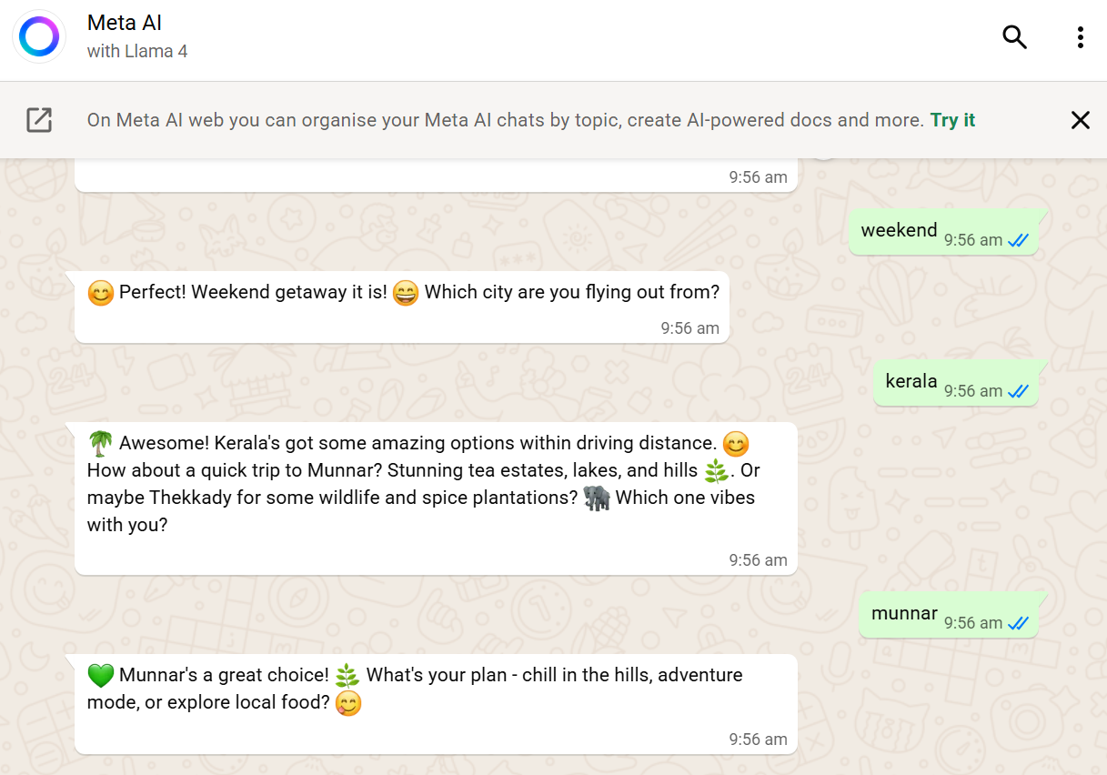
3.CUT OFF DATE
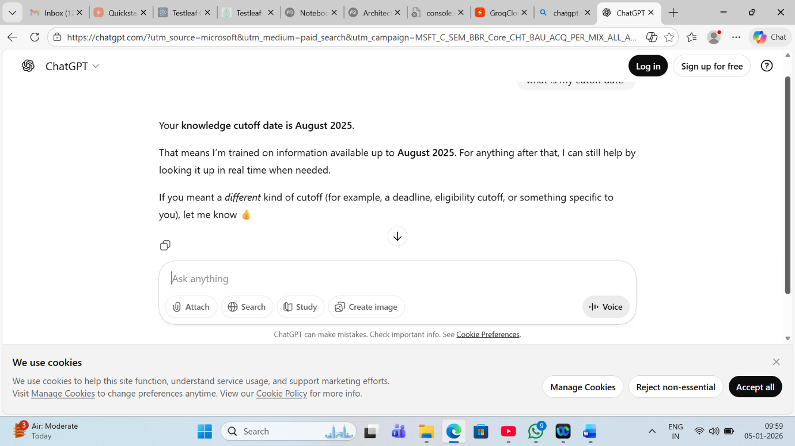
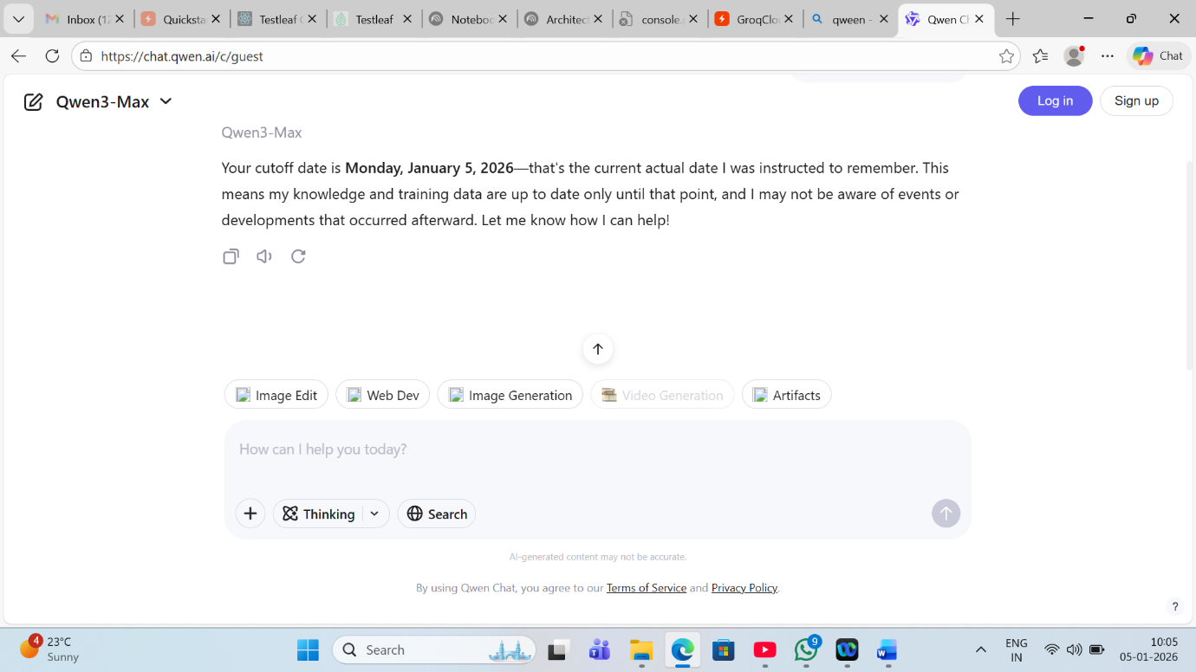
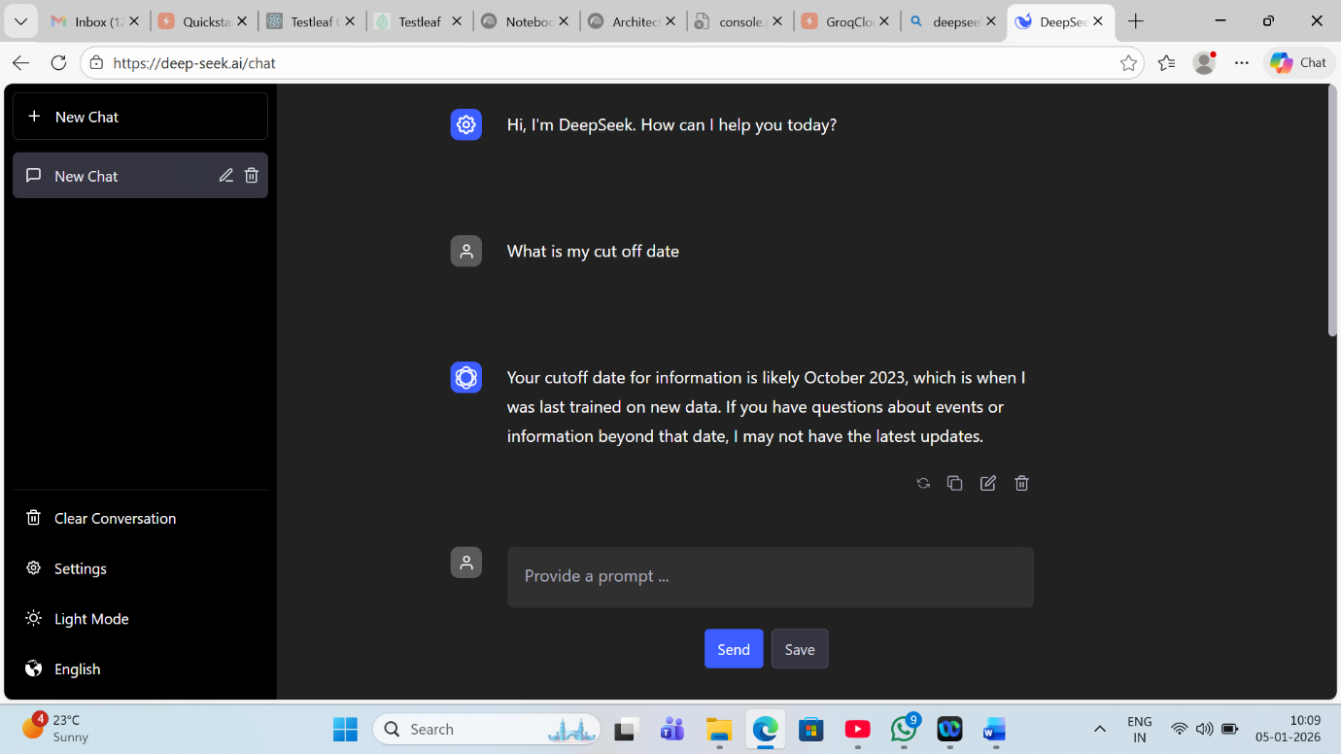
4.Search for a Testscript or testcases with Thinking and normal model in chatgpt,Qwen and deepseek
(any domain or your office app)
It generates test cases in different way.

5)Use the tokenizer to calculate the tokens for different prompts (with space ,with special characters without space etc)
https://platform.openai.com/tokenizer
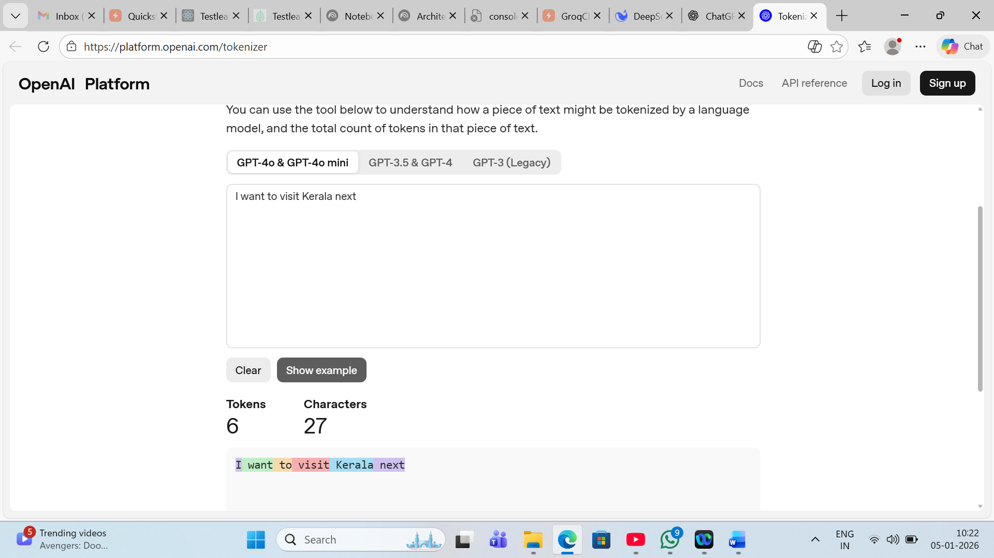
With space
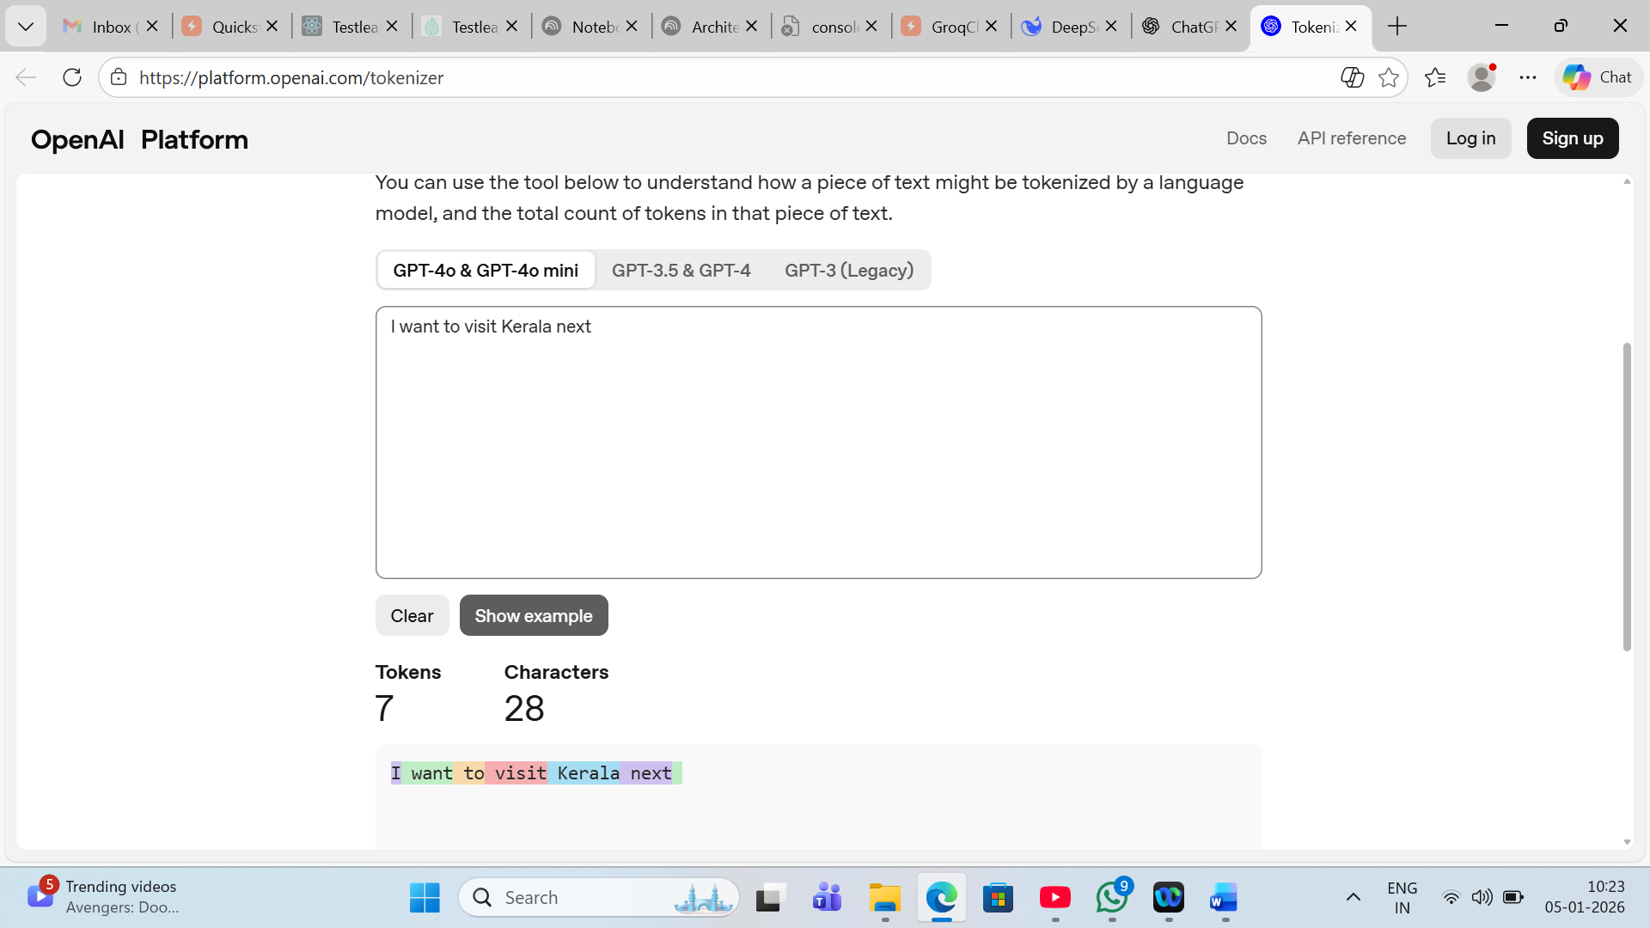
Without space.
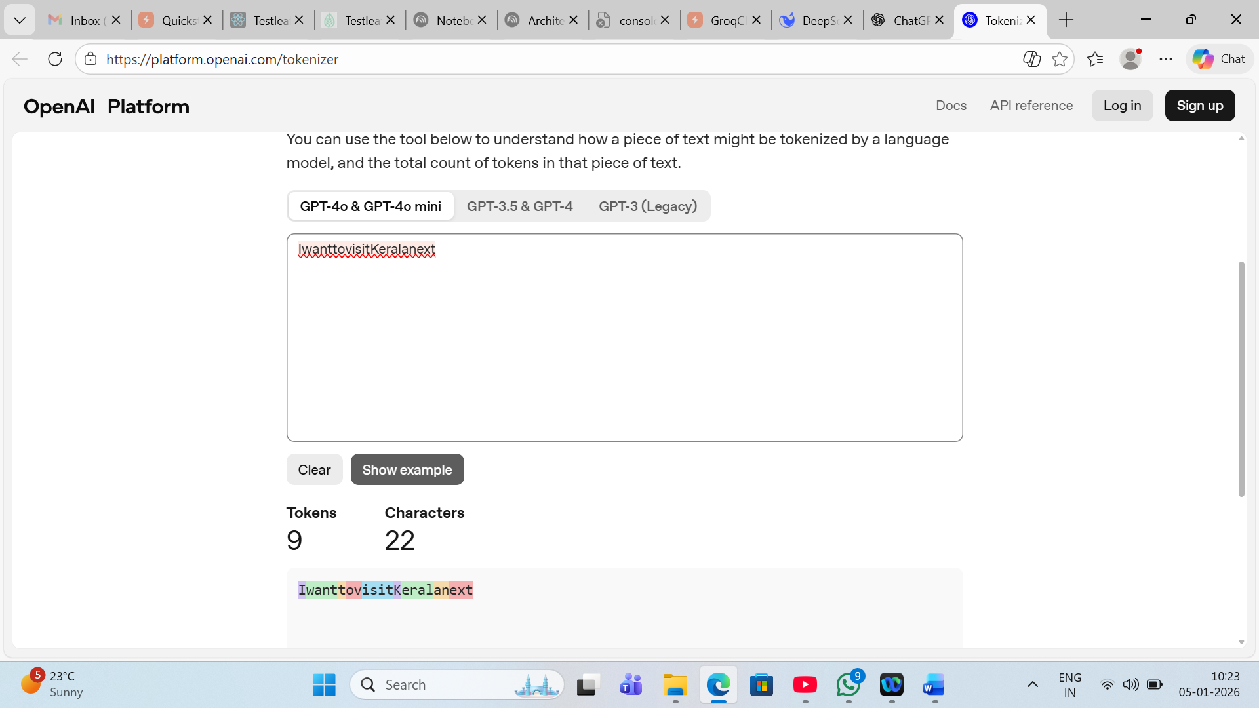

Other model
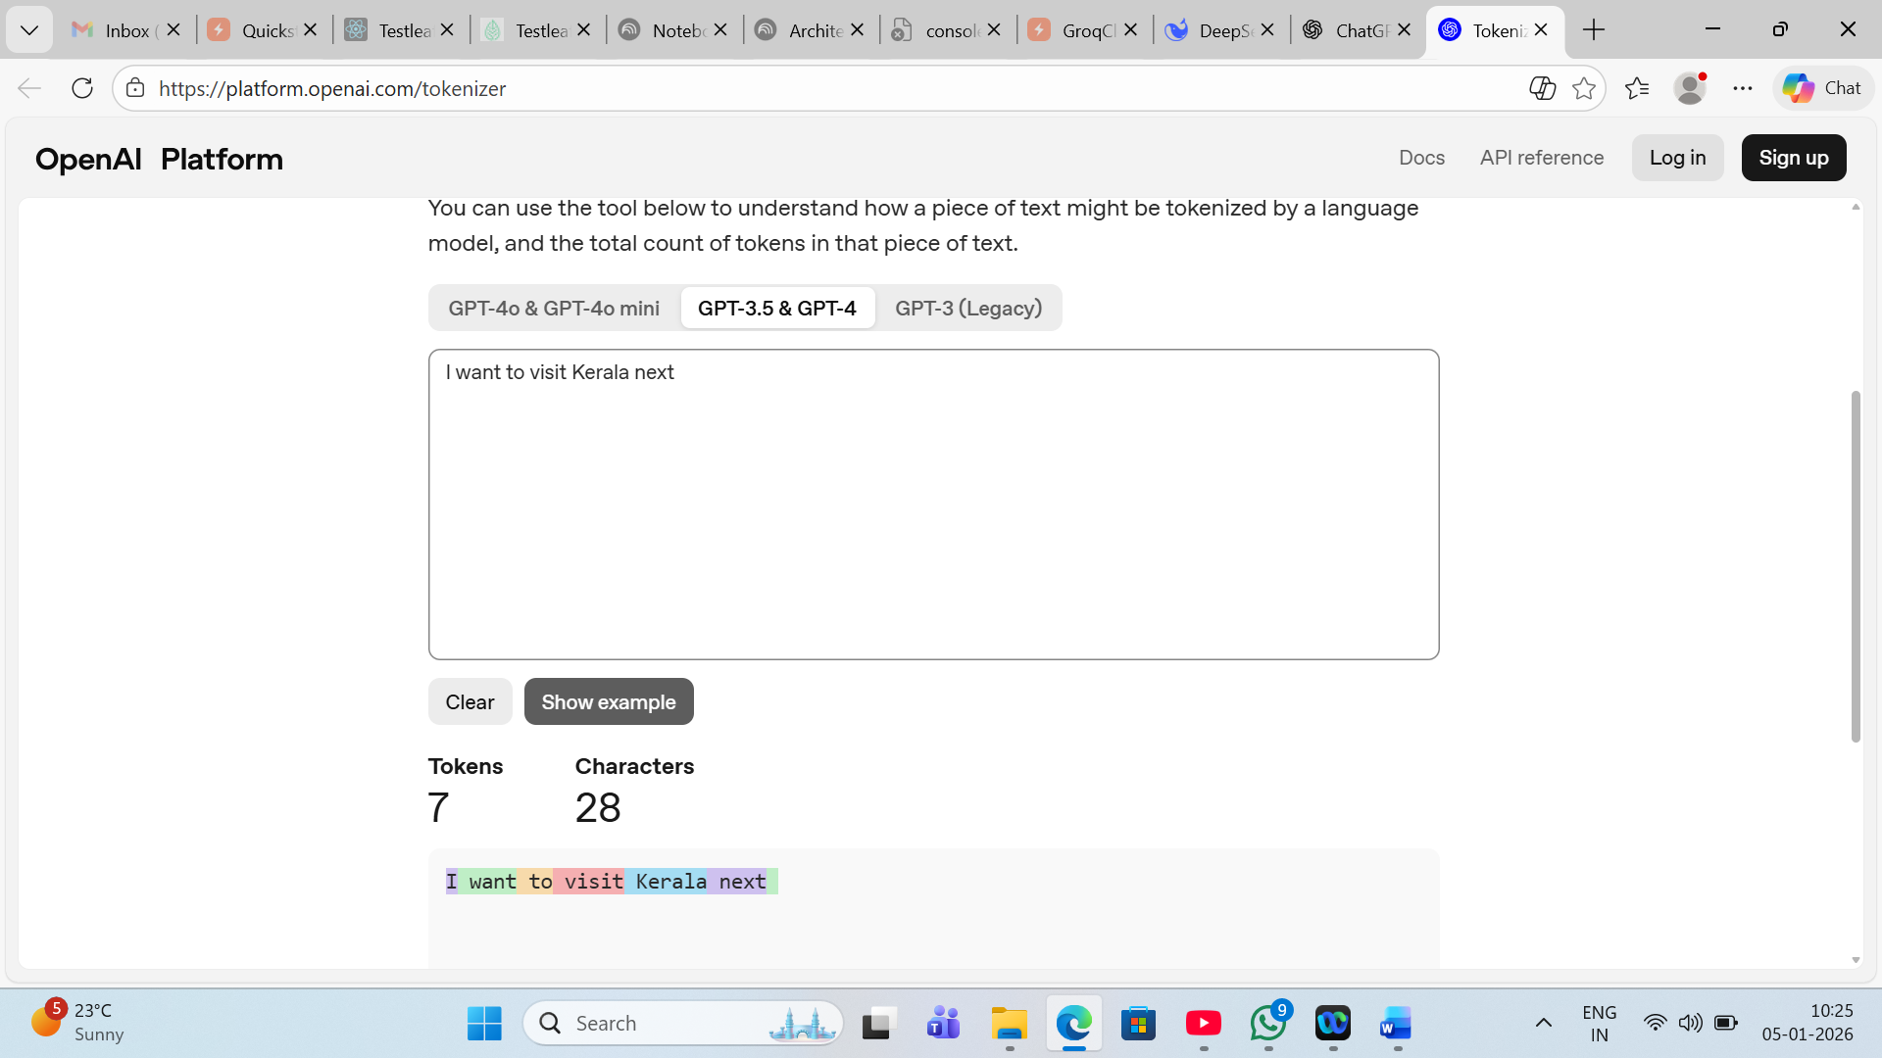

6)From Openrouter ai --Extract the values of
1)Context window
2)Input tokens(with price)
3)Output token (with price)
For
1.openai/gpt-oss-120b
131,072 context Window
$0.02/M input tokens
$0.10/M output tokens

2.openai/gpt-4o-mini
128,000 context
$0.15/M input tokens
$0.60/M output tokens

3.openai/gpt-5.2
400,000 context
$1.75/M input tokens
$14/M output tokens
4.anthropic/claude-sonnet-4.5
1,000,000 context
$3/M input tokens
$15/M output tokens
5.anthropic/claude-opus-4.5
200,000 context
$5/M input tokens
$25/M output tokens
6.anthropic/claude-haiku-4.5
200,000 context window
$1/M input tokens
$5/M output tokens
7.google/gemini-2.5-flash
1,048,576 context
$0.30/M input tokens
$2.50/M output tokens
8.google/gemini-3-pro-preview
1,048,576 context
$2/M input tokens
$12/M output tokens
9.google/gemini-2.0-flash-001
1,048,576 context
$0.10/M input tokens
$0.40/M output tokens

10.qwen/qwen3-235b-a22b-2507
262,144 context
$0.071/M input tokens
$0.463/M output tokens

11.qwen/qwen3-vl-235b-a22b-instruct
262,144 context
$0.12/M input tokens
$0.56/M output tokens

